Treatment of livestock carcasses in soil using Corynebacterium glutamicum and lysosomal application to livestock burial

Eun Seon Hong¹, Seung Hyuck Bang², Yang-Hoon Kim^{3†} and Jiho Min^{1,2*}

¹Graduate School of Semiconductor and Chemical Engineering, Chonbuk National University, 567 Baekje-daero, deokjin-gu, Jeonju-si, Jeollabuk-do 54896 Republic of Korea
²Department of Bioprocess Engineering, Chonbuk National University, 567 Baekje-daero, Deokjin-Gu Jeonju, Jeonbuk 54896, South Korea
³School of Biological Sciences, Chungbuk National University
1 Chungdae-Ro, Seowon-Gu, Cheongju 28644, South Korea

*Corresponding Author:
(Phone) +82-63-270-2436
(Fax) +82-63-270-2306
(E-mail) jihomin@jbnu.ac.kr

†Co-corresponding Author:
(Phone) +82-43-261-3575
(Fax) +82-43-264-9600
(E-mail) kyh@chungbuk.ac.kr

*,†Correspondence should be addressed to Jiho Min jihomin@jbnu.ac.kr or
Yang-Hoon Kim kyh@chungbuk.ac.kr

Submitted to Environmental Health and Toxicology

Table S1. Weight and circumference of decomposed carcass under anaerobic and aerobic conditions (weight and circumference were measured before decay (0 day) and after decay (30 day) as well as 10 days after treatment with C. glutamicum under anaerobic and aerobic conditions. (A) is weight of carcass. (B) is circumference of carcass)
(A)
Condition  (aerobic) | Sample  (g) | Time (day)
 |  | 0 | 30
Anaerobic | Control | 32.39 | 25.26
 | Treated  C.glutamicum | 35.69 | 61.23
Aerobic | Control | 40.34 | 32.60
 | Treated  C.glutamicum | 33.92 | 43.29

(B)
Condition  (aerobic) | Sample  (g) | Time (day)
 |  | 0 | 30
Anaerobic | Control | 4.23 | 4.31
 | Treated  C.glutamicum | 4.81 | 5.74
Aerobic | Control | 4.31 | 4.41
 | Treated  C.glutamicum | 4.55 | 5.98

Table S2. Weight and circumference of decomposed carcass in the presence or absence of soil (weight and circumference were measured before decay (0 day) and after decay (30 day) as well as 10 days after treatment with C. glutamicum in the presence or absence of soil. (A) is weight of carcass. (B) is circumference of carcass)
(A)
Condition  (aerobic) | Sample  (g) | Time (day)
 |  | 0 d | 30 d
Soil | Control | 31.92 | 23.33
 | Treated  C.glutamicum | 36.72 | 62.41
No soil | Control | 36.39 | 34.62
 | Treated  C.glutamicum | 33.62 | 37.83

(B)
Condition  (aerobic) | Sample  (cm) | Time (day)
 |  | 0 d | 30 d
Soil | Control | 4.42 | 4.57
 | Treated  C.glutamicum | 4.11 | 5.28
No soil | Control | 4.85 | 4.85
 | Treated  C.glutamicum | 4.88 | 4.89

Table S3. Weight and circumference of decomposed carcass at different temperatures (weight and circumference were measured before decay (0 day) and after decay (30 day) as well as 10 days after treatment with C. glutamicum. (A) is weight of carcass. (B) is circumference of carcass)
(A)
Condition  (temp.) | Sample  (g) | Time (day)
 |  | 0 d | 30 d
4 ℃ | Control | 26.49 | 22.40
 | Treated  C.glutamicum | 23.16 | 25.8
24 ℃ | Control | 24.52 | 11.3
 | Treated  C.glutamicum | 24.51 | 33.72

(B)
Condition  (temp.) | Sample  (cm) | Time (day)
 |  | 0 d | 30 d
4 ℃ | Control | 3.69 | 3.41
 | Treated  C.glutamicum | 3.47 | 3.32
24 ℃ | Control | 3.53 | 3.64
 | Treated  C.glutamicum | 3.81 | 4.72

Table S4. Change of carcass weight and perimeter according to moisture conditions (water percentage is based on culture medium. In this table, the weight of the control group is 27.31 g on day 0 and 19.81 g on day 60. The perimeter is 3.94 cm on day 0 and 3.77 cm on day 60)
 | Treated C. glutamicum
 | 0d |  | 60d
Water  (%) | Weight  (g) | Perimeter  (cm) | Weight  (g) | Perimeter  (cm)
0 | 25.62 | 3.74 | 23.28 | 3.51
1 | 28.11 | 3.91 | 10.27 | 2.41
5 | 26.78 | 3.67 | 22.01 | 4.23
10 | 27.16 | 4.01 | 7.6 | 1.65
20 | 28.39 | 3.42 | 10.92 | 2.51

Table S5. After 30 days, changed carcass weight (Control: not treated with anything. Treated: treated with C. glutamicum)
Sample  (g) | Time (day)
 | 0 d | 30 d
Control | 24.72 | 15.65
Treated  C.glutamicum | 23.65 | 30.15
Control | 25.12 | 14.05
Treated  C.glutamicum | 23.22 | 32.05

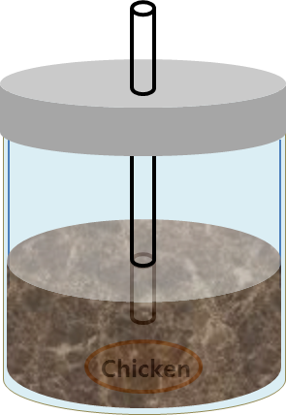

Figure S1

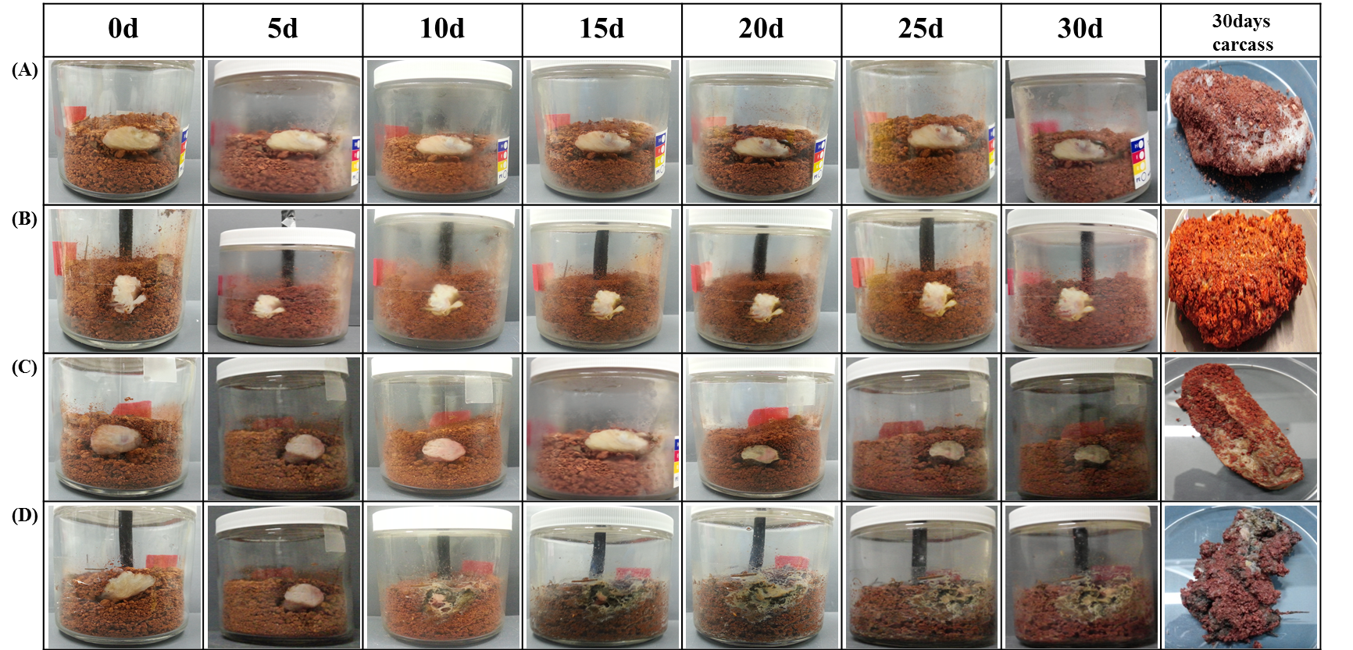
Figure S2

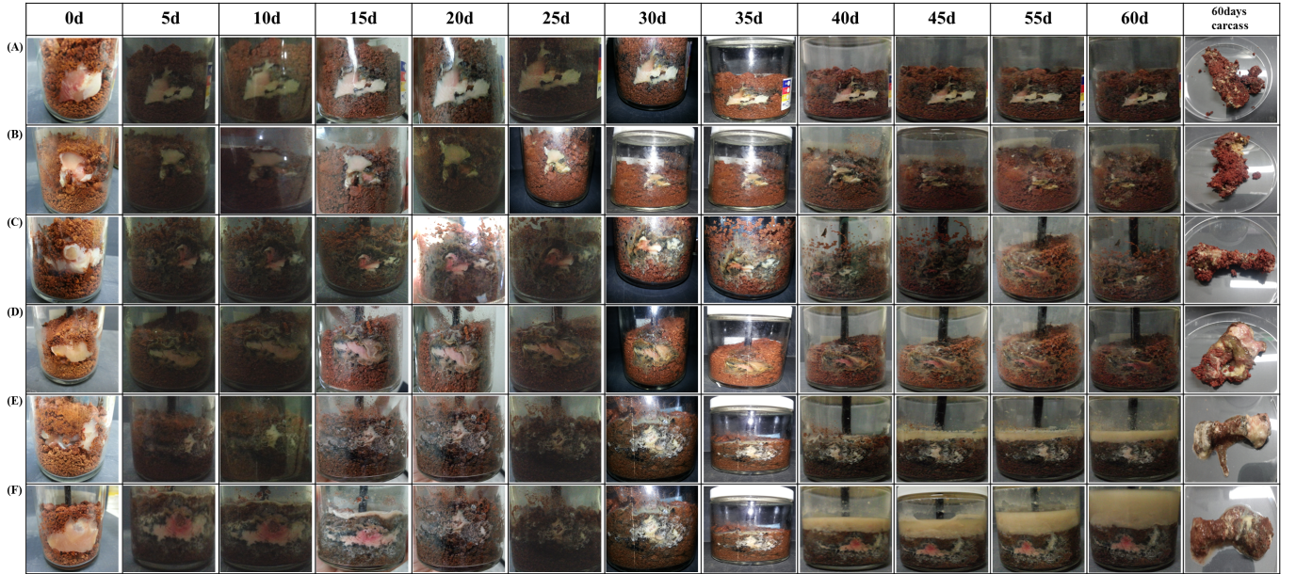

Figure S3

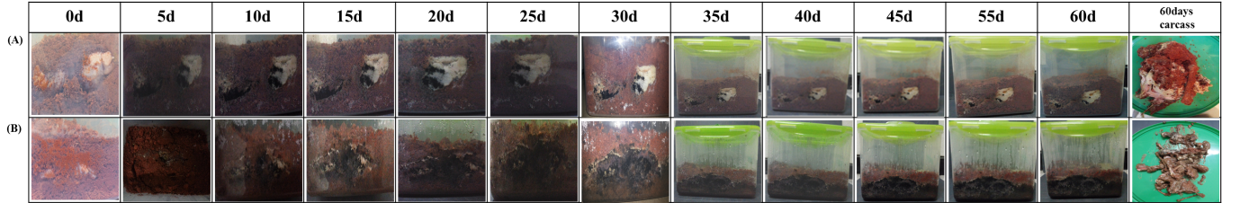
Figure S4

