Supplementary Material
Inhalation risk assessment of naphthalene emitted from deodorant balls in Korean public toilets
Yerin Jung, Pil-Gon Kim, Jung-Hwan Kwon*
Division of Environmental Science and Ecological Engineering, Korea University, 145 Anam-ro, Seongbuk-gu, Seoul 02841, Republic of Korea

*Corresponding author
Phone: +82 2 3290 3041
Fax: +82 2 953 0737
E-mail: junghwankwon@korea.ac.kr
ORCID: 0000-0002-6341-7562

- Equilibrium achievement time of a polyurethane foam passive air sampler
Considering its assumption of equilibrium state between deployed polyurethane foam passive air sampler (PUF-PAS) and air, the time when the equilibrium is reached is required before deployment of PUF-PAS in the real public toilets. A custom-made acryl chamber (inner volume of 125 L) with a mechanical fan and inlet and outlet ports for air flow was used for preliminary test of PUF-PAS. A naphthalene ball product with a diameter of 0.04 m was placed on a polypropylene weighing boat on the floor of the chamber. Air was pumped out by applying a negative pressure to the chamber using a vacuum pump. A flow meter was connected to measure the volumetric flow rate; the rate was adjusted to 20 L min^{–1} (corresponding air change rate of 10 h^{–1}). The mass of PUF-PAS disks was measured before deployment in the chamber (38.2 g ± 5.9 mg). An aluminum foil dome that served as a housing for the PUF-PAS was connected above each PUF-PAS with a fishing line to reduce potential environmental effects such as light, air flow or coarse particles. The PUF-PAS was collected and immediately placed into an amber glass bottle containing 290 mL n-hexane without headspace. The bottle containing the PUF-PASs in n-hexane were extracted at 25°C, 150 rpm for ≥ 18 h.
PUF-PAS was collected for fifth, seventh, and ninth days from the beginning of the deployment in the chamber. Naphthalene concentration in the extracts of PUF-PAS showed mean 52.3 mg L_{n-hexane}^{–1} (SD: 6.01, RSD: 0.115) during the duration of the experiment (Figure S2). Naphthalene was not detected above method detection limit (MDL) in the blank PUF-PAS.

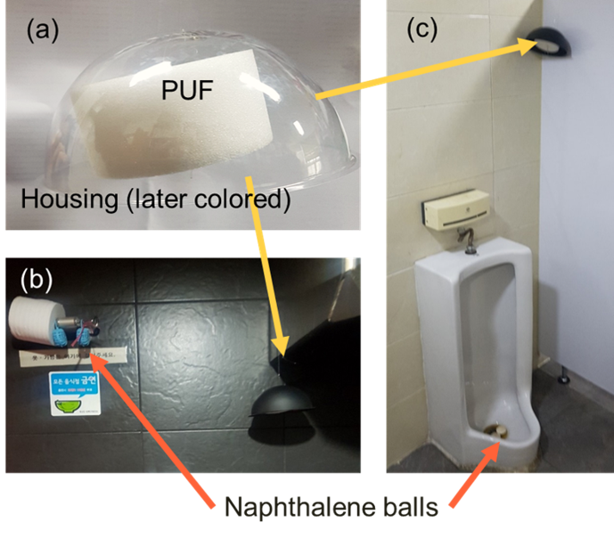
Figure S1. Polyurethane foam passive air sampler (PUF-PAS) (a) with its housing yet colored and (b, c) with black colored housing deployed in public toilets.

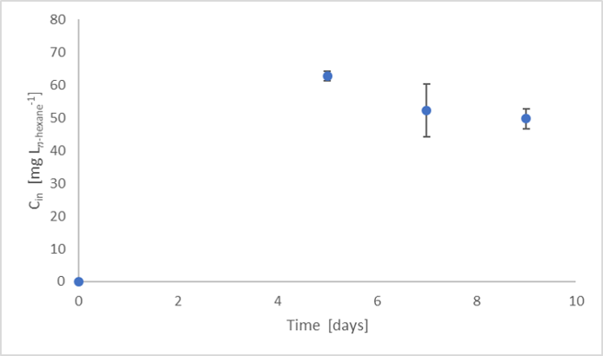
Figure S2. Kinetic of naphthalene concentration of polyurethane foam passive air sampler (PUF-PAS) with atmospheric naphthalene

